A Final Report Presented in Partial Fulfillment of the Requirements for EGR 598 – Connected and Automated Vehicles

By

Yashaswi Ranga Sivaraju

“Comparison of Smart Traffic Vendor Projects”

ARIZONA STATE UNIVERSITY

November 2022

Figure 1. ASU Logo

TABLE OF CONTENTS ii

ABSTRACT iii

LIST OF TABLES iv

LIST OF FIGURES v

INTRODUCTION 6

Statement of Purpose 6

Scope 6

Ideas 7

Definitions.…………………………………………………………………………………………………………………………………………. 8

Limitations …………………………………………………………………………………………………………………………………………. 9

LITERATURE REVIEW 9

Related Theories of the Field 9

Theorists 9

Thoughts and Arguments 9

METHODOLOGY …………………………………………………………………………………………………………………………………... 10

Participants and Partnerships 10

Equipment and Technology Used 11

DATA ANALYSIS AND RESULTS 18

CONCLUSIONS 24

Future Research 24

REFERENCES 25

# ABSTRACT

The global population recently surpassed 8 billion, and the number of vehicles on the road has increased proportionally. This accelerates the need for an intelligent traffic eco-system. As a result, understanding the various Smart Traffic vendors on the market is essential. Thus, the primary goal of the research is to compare the Intelligent Traffic Systems (ITS), also known as Smart Traffic Management systems, that are available on the market. Miovision and NoTraffic are the main companies we compare in depth. We include some information about Rhythm Engineering and Wavetronix. The ITS study focuses on distinguishing the hardware, software, and the way the company handles real-time problems that commuters face daily. Case studies from Redlands, California, Quincy, Massachusetts, Waterloo Region, and Peterborough, Ontario are included, demonstrating how Miovision and NoTraffic solve real-time traffic constraints using data collected by devices installed at intersections.

# LIST OF TABLES

Table 1. Project Estimation 7

Table 2. Capital Expenditure……………………………………………………………………………………………………………….… 16

Table 3. Operational Expenditure…………………………………………………………………………………………………………. 17

# LIST OF FIGURES

Figure 1. ASU Logo…………………………………………………………………………………………………………………………….……..1

Figure 2. Miovison Logo…..…………………………………………………………………………………………………………………….…2

Figure 3. NoTraffic Logo……………………………………………………………………………………………………………………….…..1

Figure 4. NoTraffic Partners……………………………………………………………………………………………………………………..1

Figure 5. Miovision Scout……….………………………………………………………………………………………………………………..1

Figure 6. Miovision Scout Parts………………………………………………………………………………………………………………...1

Figure 7. Miovision TrafficLink and Miovision Core…………………………………………………………………………………..1

Figure 8. Virtual Management Center………………………………………………………………………………………………………1

Figure 9. Plug & Play AI Sensors……………………………..………………………………………………………………………………..1

Figure 10. NoTraffic Apps Engine……………………………………………………………………………………………………………..1

Figure 11. Miovision Case Study - 1.1………………………………..……………………………………………………………………..1

Figure 12. Miovision Case Study - 1.2……………………………………………………………………………….………………….…..1

Figure 13. Miovision Case Study - 1.3………..…………………………………………………………………………………….….…..1

Figure 14. NoTraffic Case Study 2.1……………………….…………………………………………………………………………….…..1

Figure 15. NoTraffic Case Study 2.2……………….…………………………………………………………………………………….…..1

Figure 16. NoTraffic Case Study 2.3………………….………………………………………………………………………………….…..1

# INTRODUCTION

## Statement of Purpose

The report main goal is to distinguish between Miovision and NoTraffic. Among the comparison topics are equipment, software, system effectiveness, and real-time issues being resolved. We focus on these two because they outperform other businesses in terms of Intelligent Transportation Systems.

## Scope

The primary goal of the project was to publish a white paper comparing the accuracy and performance of AI-based traffic monitoring devices built by various market vendors. Technology evaluation, performance evaluation (including vendor performance claims), and economic benefit analysis are the three basic evaluation methodologies used in the analysis of various vendor systems. A comparison of various market solutions provides a clear picture of the current stage of development of AI-based smart traffic systems, as well as insights into how to improve current systems to address the issues that humans face. This, in turn, will assist the state Department of Transportation (DOT) in understanding current vendors and assisting them with the implementation of Smart Traffic systems across the state, reducing traffic congestion. Prerequisites for the project include Purchasing hardware for research purposes from vendors. Inquiring with the vendor about existing data and requesting it if it is available for research use. Investigating the software and hardware components of the system. Confirm the type of data being collected, who is collecting it, and the implications for privacy. Device testing on campus as a real-time test case scenario. The project deliverables are a white paper comparing the various AI-based smart traffic devices on the market. The project does not modify the device software or hardware. It also excludes the testing and development of AI-based algorithms. The project success variables are intended to put the equipment to the test, effectively evaluating its efficiency and performance. The project constraints included no communication with vendors to obtain a project estimate, information of the devices being used, and software that is being implemented. The cost of procuring the devices is cost prohibitive. There were problems with the collaboration between ASU Collaboratory and COX, so the project was put on hold.

| Milestones | Estimated Date of Completion |
| --- | --- |
| 1. Project Start | 5 August 2022 |
| 2. Scope Statement | 2 September 2022 |
| 3. Research on Florida DOT policies | 10 September 2022 |
| 4. Updates on the procurement of equipment from vendors | 20 September 2022 |
| 5. Literature review & vendor platform purchase | 30 September 2022 |
| 6. Creating a set-up for evaluation | 10 October 2022 |
| 7. Evaluating different vendor technologies strength and weakness | 30 October 2022 |
| 8. Conduct preparation studies for future real-world performance evaluation | 25 November 2022 |
| 9. Scientific White Paper drafting | 1 December 2022 |
| 10. White Paper Review | 20 December 2022 |
| 11. Deliver Final report / Presentation | 30 December 2022 |
| Total Estimated Length of Project | 147 Days (21 weeks) |

*Table 1: Project Estimation*

## Ideas

The main idea of companies working on Traffic Management Systems is to install hardware at multiple intersections using camera modules, batteries, wireless fidelity, and other components, and then upload the data to the cloud, analyze the data, and create vehicle-to-everything connectivity. Furthermore, the analysis is used to develop an efficient solution for traffic signals so that traffic congestion is reduced, pedestrians are prioritized, and accident prevention is based on vehicle connectivity to everything. The data gathered tells us when peak traffic hours are, the number of vehicles, pedestrians, which turn, which U turn, and many other things.

# Definitions

**Automatic Traffic Signal Performance Measurement (ATSPMS)**

These tools modernize traffic signal management by supplying high resolution data to support goals and performance-based maintenance and operating plans that increase safety and efficiency while reducing congestion and costs.

**Transportation Management Center (TMC)**

The majority of highway management systems hub or nerve center is called the Transportation Management Center (TMC).

**Automatic Traffic Recorder (ATR)**

A permanent device in the pavement that collects traffic data automatically and continuously.

**Corridor Level of Service**

Corridor level of service is a performance metric used to classify traffic flow that is based on vehicle speed, density, and congestion.

**Virtual Management center (VMC)**

The VMC is a managed service provided by NoTraffic to customers, providing 24/7/365 coverage and ensuring that someone is always keeping an eye on the intersections. The system includes safety notifications and automation processes to help traffic engineers and agencies on a routine basis.

**Plug & Play AI sensors**

At every intersection, NoTraffic sensors are mounted to provide detection and categorization of any road user using a combination of computer vision and radar. For city-grid coordination, anonymized processed data is sent to the cloud.

**NoTraffic Apps Engine**

The NoTraffic Apps Engine collects sensor data from each intersection on the grid, providing traffic engineers and city officials with valuable insights.

**DSRC – D**edicated **S**hort **R**ange **C**ommunication

**CV2X – C**ellular **V**ehicle to **E**verything

# Limitations

A physical device to test and analyze is highly expensive to buy. Since there are no set regulations that the Department of Transportation (DOT) follows and regulations are amended in response to problems encountered, it is challenging to determine whether the devices comply. The collaboration between COX and ASU Collaboratory was the main obstacle in this project; because of the discrepancies, the project was delayed and could not reach the position on schedule. There was no response from the companies or vendors, which was a huge issue for moving on with the project.

# LITERATURE REVIEW

## Related Theories of the Field

A Comparative Study of IoT Based Smart Traffic Management System by Sunny Hossain and Farzana Shabnam distinguished between "IoT Devices for Traffic Management System," "An IoT based Automated Traffic Control System based on Real Time Capability," "An IoT Platform for vehicle traffic monitoring and controlling system based on priority," and "IoT based traffic monitoring and controlling system based on IoT platform for vehicle traffic monitoring and controlling system." As the name implies, despite certain similarities, they quantified their approaches to resolving traffic problems in a distinctive way, but the goal remained the same, notably, to resolve traffic concerns.

## Theorists

**Sunny Hossain**

Department of Electrical and Electronic Engineering, BRAC University, Dhaka, Bangladesh

**Farzana Shabnam**

Department of Electrical and Electronic Engineering, BRAC University, Dhaka, Bangladesh

## Thoughts and Arguments

The project being discussed, and the paper written by Sunny Hossain and Farzana Shabnam have similarities. The commonality is that both are inclined to comprehend the key distinctions between the many technologies that can be used. The project provided attempts to compare businesses that adopted a certain hardware or software and developed it and are constantly updating those to put them in the real world, whilst the other has been a beneficial document to understand which technology should be utilized at the beginning.

# METHODOLOGY

## Participants and Partnerships

The major vendors that we targeted are Miovision and NoTraffic.

1)



Figure 2: Miovision Logo *(*<https://miovision.com/>*)*

**Miovision Acquisitions** - Traffop and Rapid Flow

2)



Figure 3: NoTraffic Logo *(*[*https://notraffic.tech/*](https://notraffic.tech/)*)*

**Partners**

  

  

Figure 4: NoTraffic Investors *(*[*https://notraffic.tech/*](https://notraffic.tech/)*)*

## Equipment and Technology Used

### Miovision

* **Scout Explorer**

The technologies used and how they work:

Built-in cellular connectivity allows for the collection of speed data, which immediately enables the development of an ATR study. The system then processes the video and sends it to the cloud for access and validation.  The study would not stop when the batteries need to be changed because it contains four batteries, so while one is being changed, another is still operating. 4 batteries have a 12-day operating life. Making items into counts and exporting them as useful counts are post-configuration actions.

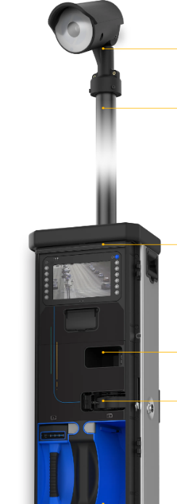

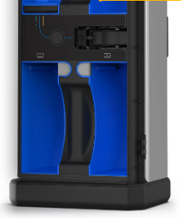

Figure 5: Miovision Scout *(*<https://miovision.com/>*)*

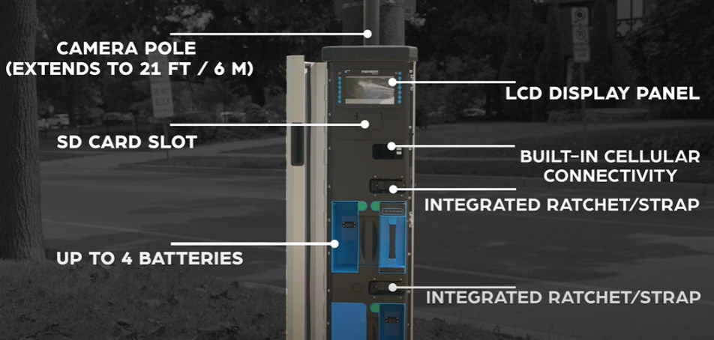

Figure 6: Miovision Scout Parts *(*<https://miovision.com/>*)*

Onboard video processing is made possible by cellular connectivity and AI algorithms. Multimodal volume counts (ATRs), speed, and pedestrian/bicycle pathway data are automatically uploaded. All sections are included in the 1.2 m (4 feet) tall equipment. It takes about 15 minutes to set up and even less time to take down. HD camera with a 124° HFOV lens

* **TrafficLink**

TrafficLink offers industry-leading performance measurements and useful insights in addition to allowing you to remotely administer and monitor your traffic network. It utilizes cutting-edge Computer Vision techniques to remotely discover, monitor, and investigate problems. You can keep track of the most recent traffic metrics and scenario updates on Miovision TrafficLink.

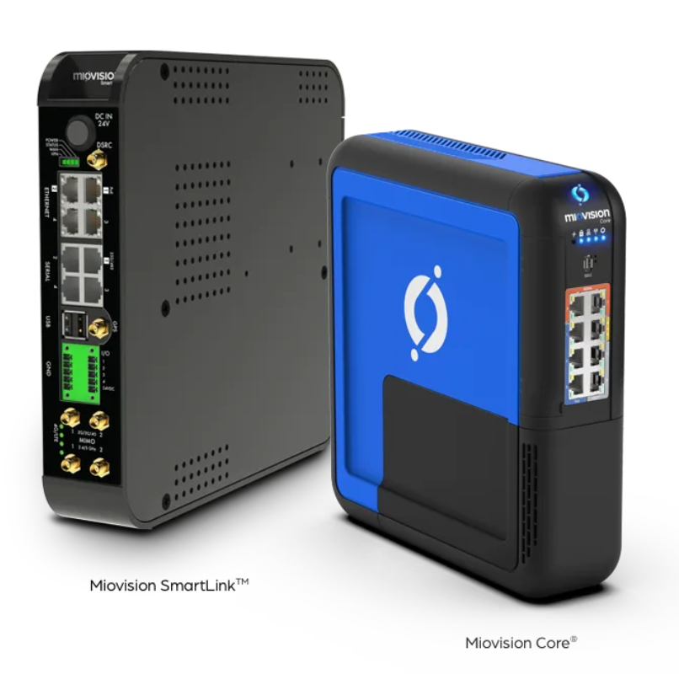

Figure 7. Miovision TrafficLink and Miovision Core *(*<https://miovision.com/>*)*

* **Miovision Core**

The hardware platform from Miovision that will eventually replace Miovision SmartLinkTM and Miovision SmartSense is called Miovision Core. With expanded capabilities to run more complex software solutions at the intersection, Miovision Core offers two times the processing power of Miovision SmartLink. Miovision Core DCM, a small plug-in module, increases video computing power by more than 50% to support computer vision-based solutions such as video detection and multimodal traffic counts.

* **SmartLink**

Data from your current controllers and cabinet devices is transformed into insightful information by Miovision SmartLink. Using a secure VPN tunnel, communication with your traffic cabinets is established. The intersection data collection is safely stored in the cloud. When you require access to your data, it will be available quickly. The modern traffic controllers (Naztec, Econolite, Siemens, McCain, Peek, Intelight, etc.) are compatible with Miovision SmartLink, enabling a seamless integration. a variety of antennae, including WiFi, GPS, 2G, 3G, and LTE. access to even the most distant traffic cabinets. provides important metrics from the side of the road to assist you in making decisions.

* **Miovision and Amazon**

Miovision uses AWS IoT and Smart Devices. Amazon Web Services offers the miovision IT solutions. The entire technological foundation of Miovision is based on AWS IoT.  Petabytes of real-time video and sensor data are processed by Miovision data pipeline using Amazon Kinesis (Kinesis), and the processed data is then sent to Amazon DynamoDB (DynamoDB).  For compute services that enable analytics, user experiences, and internal business processes, the organization employs Amazon Elastic Compute Cloud (Amazon EC2). It also uses serverless compute from AWS Lambda (Lambda) to allow interoperability between various services.

RapidFlow and Spectrum are businesses that utilize Miovision services.

### NoTraffic

* **Virtual Management Center**

NoTraffic AI-based technology is under the human oversight of the Virtual Management Center. Operators prioritize preventive monitoring, optimization, and quick fixes. To make sure that efficiency and safety are constantly top of mind, they also investigate the system for data that might be helpful for both customers and product teams. This enables NoTraffic to solve any issues as they arise and may enable it to identify client challenges earlier than rivals.

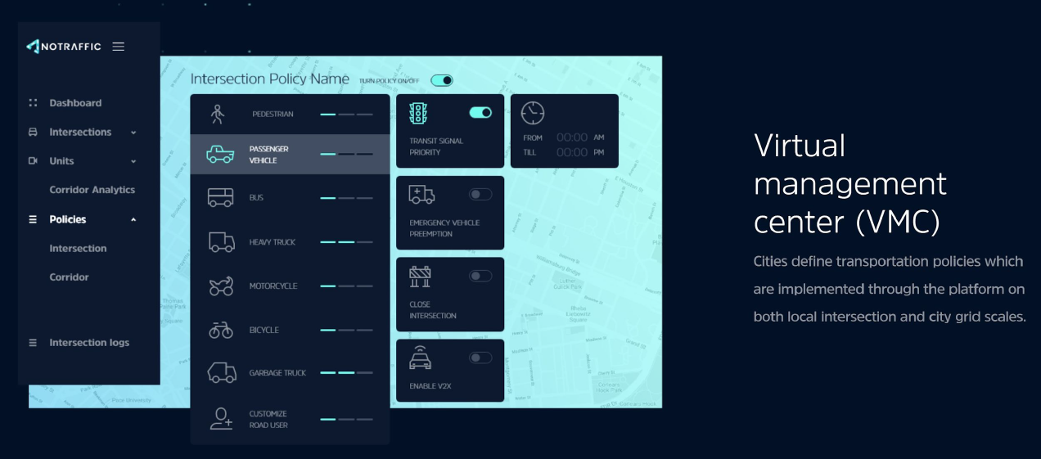

Figure 8. Virtual Management Center *(*[*https://notraffic.tech/*](https://notraffic.tech/)*)*

* **Plug & Play AI sensors**

With a simple installation of plug-and-play AI sensors from NoTraffic, intersections may be linked to a managed grid in less than two hours. Any form of road user can be categorized by them, including emergency vehicles, lorries, buses, cars, pedestrians, and bicycles. The sensor units also have DSRC and C-V2X connected vehicle capabilities, expanding the possibilities for smart technology on the road.

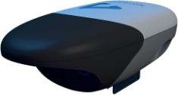

Figure 9. Plug & Play AI Sensors *(*[*https://notraffic.tech/*](https://notraffic.tech/)*)*

* **NoTraffic Apps Engine**

The NoTraffic Apps Engine is installed in the traffic light cabinet and integrates with all current traffic controllers. To improve residents quality of life, the Traffic Apps Engine enables a rich ecosystem of mobility apps and services.

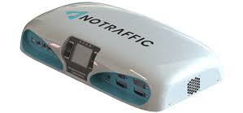

Figure 10. NoTraffic Apps Engine *(*[*https://notraffic.tech/*](https://notraffic.tech/)*)*

NoTraffic offers a comprehensive solution that includes software, a camera-radar sensor unit, and an SAS-based traffic-management platform. An initial deployment typically consists of 10 to 15 intersections, with the possibility of more. Three critical components are also included in the company technology. The first is a collection of four proprietary sensors, one for each approach, that include a camera with machine vision and a small automotive-grade radar in a box. Other inputs are also possible, such as signals from connected vehicles. The sensor units can detect objects approaching the intersection from up to 900 feet away (274 meters). At the human-eye level, the system distinguishes traffic and estimates each vehicle arrival time at the intersection. Although some of NoTraffic AI is shared with cloud-based computers, an Nvidia-powered "edge-computing device" is installed in the intersection cabinet. The installation takes about an hour, but once completed, it is ready to use. NoTraffic has partnerships with companies like AT&T. Finally, NoTraffic employs cellular communications to generate a network effect through the cloud. Rather than sending full-streaming video or other large files, the nodes exchange a set of extrapolated lightweight metadata about the vehicle types, latitude-longitude, speed, and direction. Latency is claimed to be low.

### Cost of acquiring

#### Miovision

##### Capital Expenditure

|  |  |  |  |
| --- | --- | --- | --- |
| Description | Qty | Price | Total |
| Miovision Scout Connect Video Collection Unit | 2 | $5,000.00 | $10,000.00 |
| Scout Video Control Unit | 2 | Included | $0.00 |
| Scout Pole mount | 2 | Included | $0.00 |
| Scout Connect Shipping & Handling | 2 | Included | $0.00 |
| Shipping & Handling | 1 | $0.00 | $0.00 |
|  |  | Subtotal (Net) | USD 10,000.00 |
|  |  | Tax Total |  |
|  |  | Total | USD 10,000.00 |

*Table 2. Capital Expenditure*

##### Operational Expenditure

|  |  |
| --- | --- |
| Description | Rate |
| Intersection Count (1 hour) | $21.00 |
| Intersection Count with Premium class (1 hour) | $24.00 |
| Light Goods Vehicle - Intersection Counts (1 Hour) | $2.00 |
| Crosswalk Data (1 hour) | $2.00 |
| Intersection Count 24+ Hour Study (1 hour) | $16.67 |
| Intersection Count 24+ Hour Study with Premium Class (1 hour) | $18.00 |
| Travel Time Report Generation (1 hour) | $15.00 |
| Travel Time Report Generation (24 hour) | $12.50 |
| Road Volume Count (1 lane-hour) | $2.00 |
| Road Volume Count with Premium Class (1 lane-hour) | $3.00 |
| Light Goods Vehicle - Road Volume Counts (1 lane-hour) | $0.25 |
| Small Roundabout (1 hour) | $36.00 |
| Small Roundabout with Premium Class (1 hour) | $39.00 |
| Large Roundabout (1 hour) | $76.00 |
| Large Roundabout with Premium Class (1 hour) | $79.00 |
| Light Goods Vehicle - Roundabout Counts (1 hour) | $2.00 |
| Pathway Volume (1 lane-hour) | $6.00 |
| Junction Count (1 hour) | $18.00 |
| Intersection Right Turn on Red | $2.00 |
| Rush Turnaround - 48 hours | $3.00 |
| Rush Turnaround - 24 hours | $7.00 |

*Table 3. Operational Expenditure*

#### NoTraffic

We did not have any information about the costs of acquiring the device and using their platforms because the NoTraffic vendor did not respond.

# DATA ANALYSIS AND RESULTS

We had to use data provided by customers as well as case studies presented by companies because we did not have any specific devices to work on.

## Case studies of Miovision

**Region of waterloo:**

**Aim:** The Region of Waterloo required an efficient, effective, and modern network management solution to enable a relatively small traffic operations team to monitor and manage an expansive and increasingly complex transportation infrastructure.

The Region traffic operations team receives immediate alerts of road or infrastructure incidents via Miovision TrafficLink, allowing the team to:

• Remotely monitor and resolve incidents

• Use infrastructure alerts to prioritize maintenance resources

• Remotely monitor and resolve incidents

• Send automated traffic alerts to transit and emergency medical services.

A collision at one of the region busiest intersections in June 2016 clearly demonstrated how the TrafficLink platform is assisting the Region traffic team. When the collision occurred, the performance metrics in TrafficLink clearly demonstrated that there was a problem by:

• A significant increase in travel time along the corridor

• A significant decrease in southbound vehicle volumes

Within minutes of the accident, these metrics alerted city engineers. Engineers began remotely monitoring the situation in real-time as soon as they became aware of the collision via the SmartView 360 camera. Instead of waiting for citizen complaints, the team was able to act quickly, dispatching the necessary resources to resolve the issue.

**City of Peterborough:**

The City of Peterborough launched a pilot project to compare traditional signal timing systems with adaptive signal systems using Miovision TrafficLink solutions and Miovision Surtrac adaptive traffic signal control systems. The project saved nearly $1 million in user costs, reduced vehicle emissions by 20%, reduced vehicle delays by 41.3%, and reduced split failures by 46.4%.

**Travel time:**

The city was able to identify and contrast travel time disparities between the adaptive signal timing and TOD systems using Miovision TrafficLink dashboards. Adaptive control and TOD control maintained comparable travel times along the corridor during off-peak traffic flow periods. Vehicles traveling at the speed limit through the testing region in free-flow traffic took 126 seconds, assuming no stops. The average travel time through the corridor with the current TOD control during peak hours was roughly 253 seconds in the eastbound direction and 270 seconds in the westbound direction. Travel time across the corridor was cut by roughly 28 seconds (11%) in the eastbound direction and 80 seconds (30%) in the westbound direction compared to the adaptive control system.

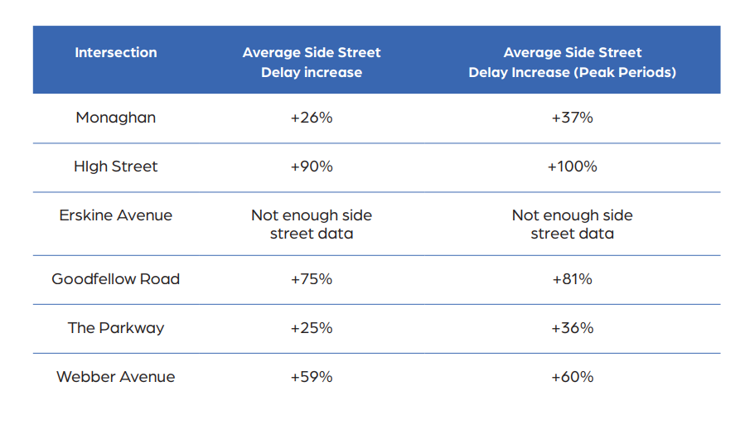Figure 11: Miovision Case Study – 1.1 *(*<https://miovision.com/>*)*

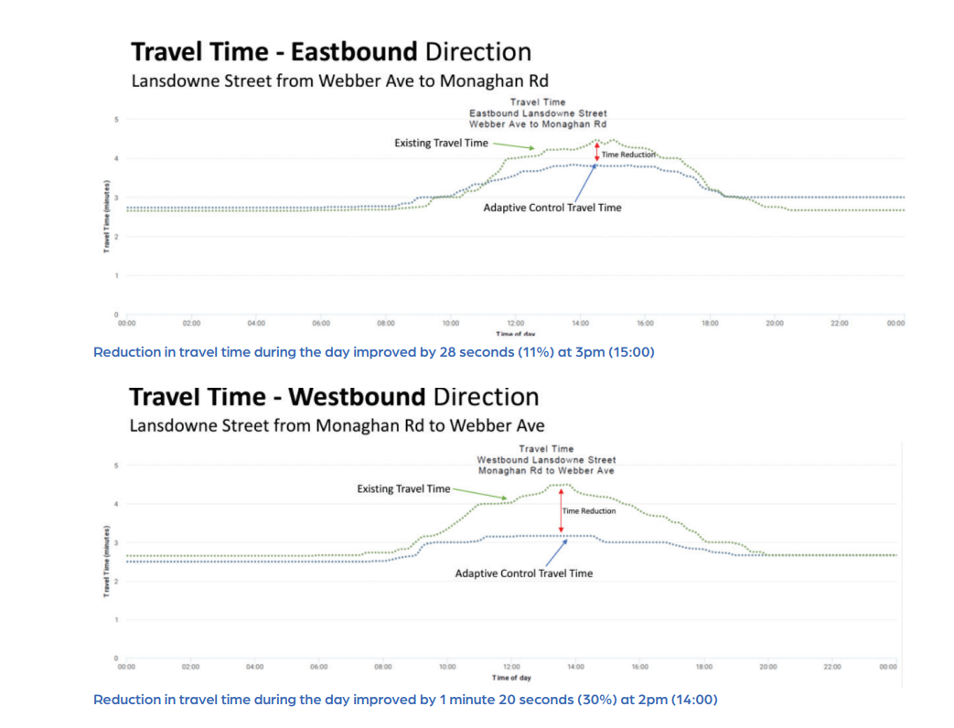

Figure 12: Miovision Case Study – 1.2 *(*<https://miovision.com/>*)*

**Side Street Vehicle Delay**

According to Miovision TrafficLink, the adaptive control system increased side street vehicle delay by 63% during peak periods. This was a foregone conclusion because the adaptive software automatically adjusts the signal timing to current traffic conditions by reallocating green time from side streets to manage the heavier traffic flow on the main street. Side street delay was found to be most pronounced at intersections with high turning volumes or where geometric deficiencies interfere with side street vehicle ability to utilize available green time.

**Corridor Stops**

When there is not enough green time, vehicles are obliged to halt on the major thoroughfare street, which is known as a corridor. According to TrafficLink, the adaptive signal system on Lansdowne Street reduced corridor pauses by 37% in the eastbound direction and 53% in the westbound direction. The entire travel time along the corridor was cut in half by this important performance indicator. Congestion, delays, and travel times were decreased thanks to the adaptive signal management system and TrafficLink performance metrics, which also increased service levels in both eastbound and westbound directions. The entire elevated service level translates into a roughly 6% increase in corridor capacity.

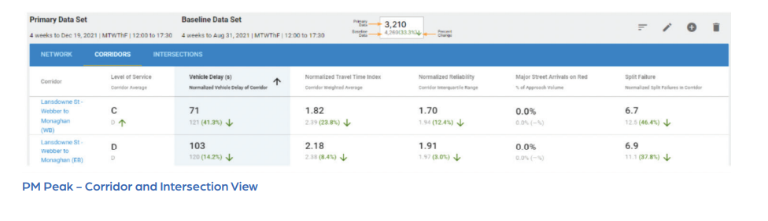

Figure 13: Miovision Case Study – 1.3 *(*<https://miovision.com/>*)*

**User Cost Savings**

Using Miovision TrafficLink with the adaptive control signal system, there was an overall reduction in user travel time in the pilot study area. The results of the pilot estimated travel time savings over a typical year to be approximately $977,000 in reduced user costs. User cost savings are calculated as the value of reduced delay time for vehicle passengers, multiplied by the average vehicle occupancy (1.2 for cars and 1.0 for trucks). They are based on the median hourly wage rate for all occupations ($19.64 / hr for passenger vehicles and $55.24 / hr for trucks). According to estimates, the adaptive signal management system within the pilot corridor saved around 106,700 liters of fuel yearly, saving an additional $213,000 per year at an average fuel price of $2.00 per liter. Within the research region for the pilot project, the decrease in fuel use by drivers is thought to have resulted in a yearly reduction of 273 tons of CO2 emissions.

**Results:**

The City of Peterborough created compelling and thorough data insights, reports, and analyses using Miovision TrafficLink and Surtrac adaptive traffic signal control systems to present to traffic ministries, agencies, and other stakeholders.

## Case studies of NoTraffic

NoTraffic was chosen by the City of Redlands, California, to provide a technical demonstration of advanced traffic management tools that could meet the city evolving need for ITS solutions. The NoTraffic platform provided the following benefits to city residents in just two months of optimization, with installations at only 2% of city signals.

59% - Direct cost savings

900hours - Delay Eliminated

$331,380 - Economic Benefit

11 Tons - Emissions Reduced

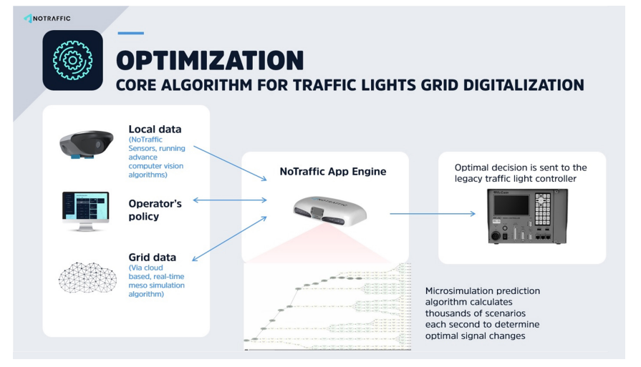

Figure 14: NoTraffic Case Study 2.1 *(*[*https://notraffic.tech/*](https://notraffic.tech/)*)*

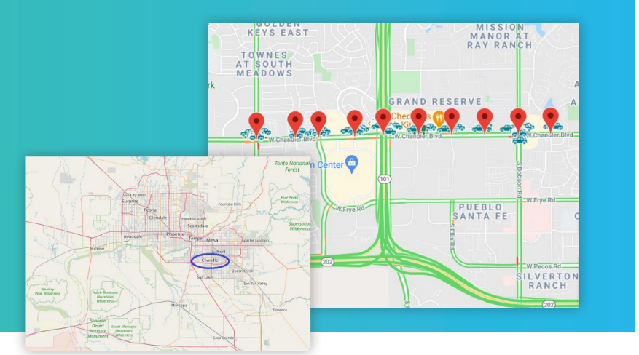

Figure 15: NoTraffic Case Study 2.2 *(*[*https://notraffic.tech/*](https://notraffic.tech/)*)*

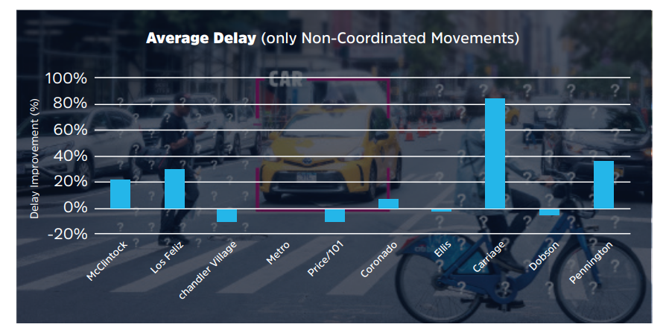

Figure 16: NoTraffic Case Study 2.3 *(*[*https://notraffic.tech/*](https://notraffic.tech/)*)*

# CONCLUSIONS

As a result, we can conclude that if we have a detailed comparison on what exactly the vendors are using and how efficient the vendor products are and which stage is the current stage of development is, we can understand predict by when we can have less congestion and fewer accidents on the road. Also addressing the ways to improve Intelligent traffic segments, as well as specific software and hardware that can be used.

## Future Research

When the technologies are commercialized, the prices of the devices will tumble, giving us a better opportunity to work on the comparison. Future work will include gaining access to the devices and services provided by the vendors, which will allow us to analyze the devices in detail without prejudices.

# REFERENCES

|  |  |
| --- | --- |
| [1] | S. Hossain and F. Shabnam, "A Comparative Study of IoT Based Smart Traffic Management System," 2021 IEEE International Women in Engineering (WIE) Conference on Electrical and Computer Engineering (WIECON-ECE), 2021, pp. 125-128, doi: 10.1109/WIECON-ECE54711.2021.9829636. |
| [2] | <https://www.sae.org/news/2020/12/traffic-light-automation?utm_source=google&utm_campaign=TN_Edge_PH> |

[3] <https://www.cbinsights.com/company/notraffic>

[4] <https://notraffic.tech/>

[5] <https://miovision.com/>

[6] <https://notraffic.tech/media-analysts/>